Test Case: tc001_SPX_Dev5_Crear_Solicitud_Articulo_Almacen
Step 1 - Enter username and password and click to button Enter : Credentials Entered
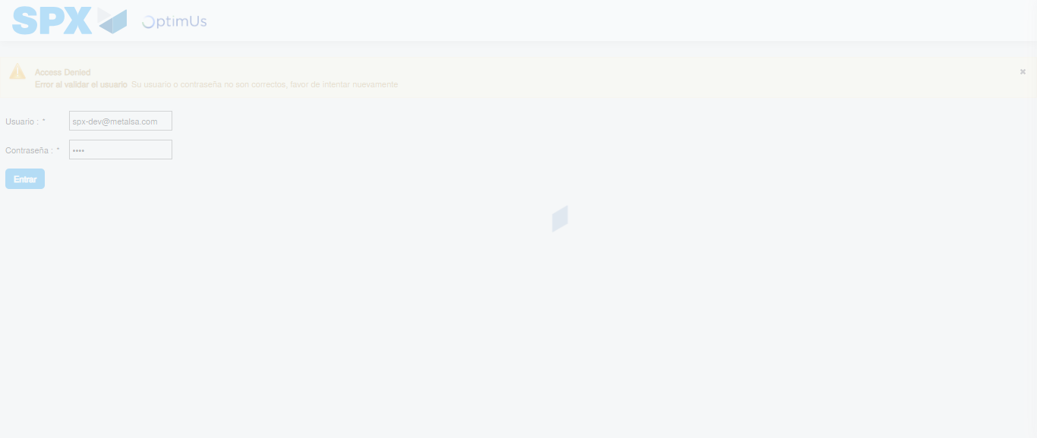Image file-name: QC_Testing-tc001_SPX_Dev5_Crear_Solicitud_Articulo_Almacen-1787864083205

Step 2 - Select to UEN and Access to Request for a New Inventory Item : UEN Correctly selected and Correct access
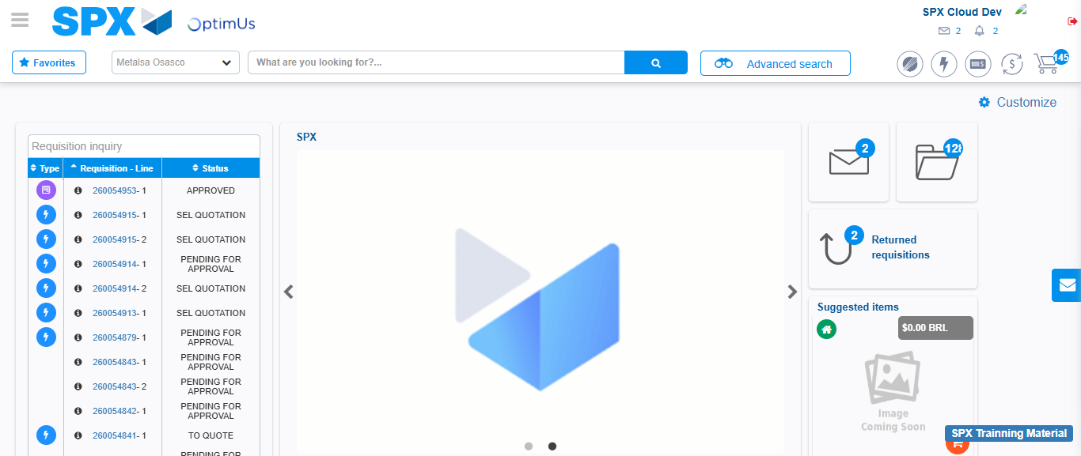Image file-name: QC_Testing-tc001_SPX_Dev5_Crear_Solicitud_Articulo_Almacen-1787864109958

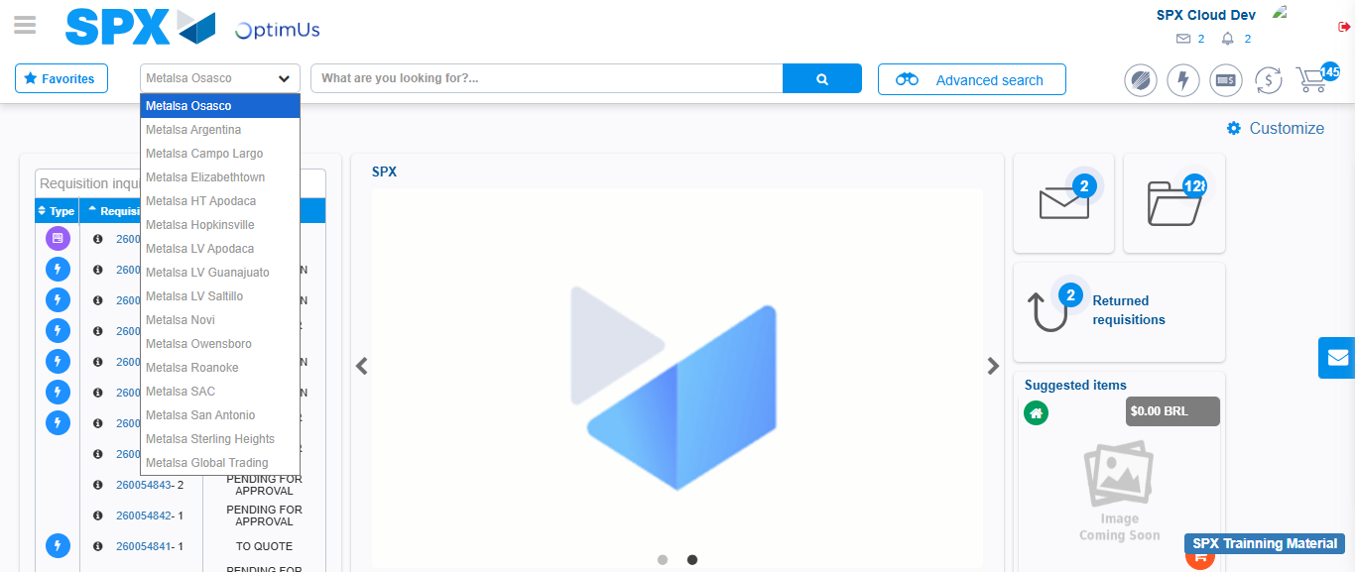Image file-name: QC_Testing-tc001_SPX_Dev5_Crear_Solicitud_Articulo_Almacen-1787864110498

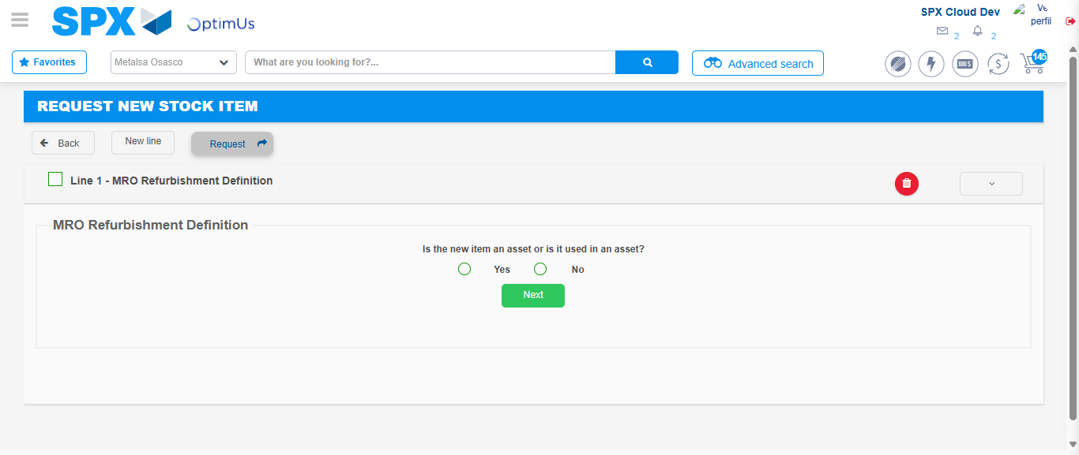Image file-name: QC_Testing-tc001_SPX_Dev5_Crear_Solicitud_Articulo_Almacen-1787864131152

Step 3 - Select options first section : Options seleted correctly
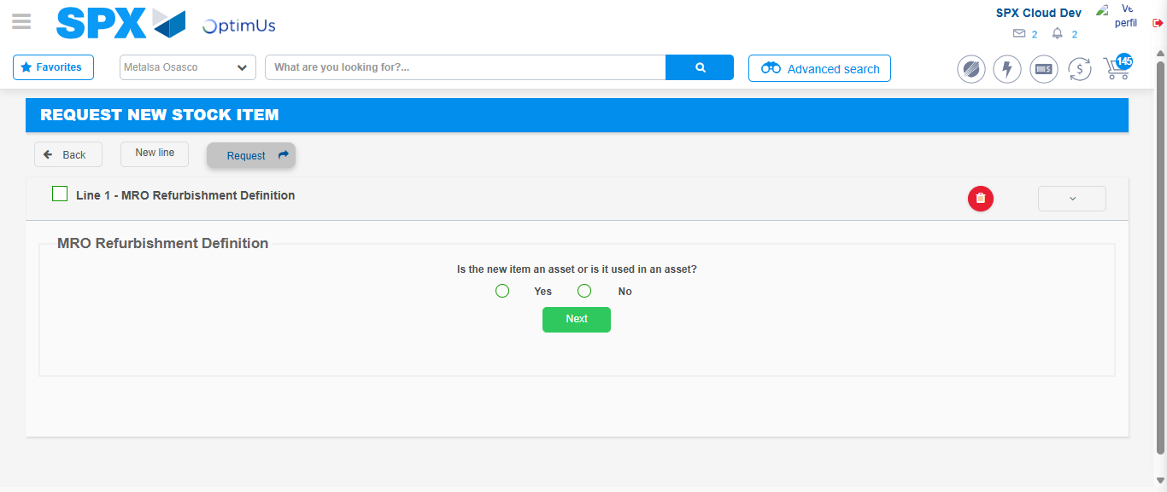Image file-name: QC_Testing-tc001_SPX_Dev5_Crear_Solicitud_Articulo_Almacen-1787864131457

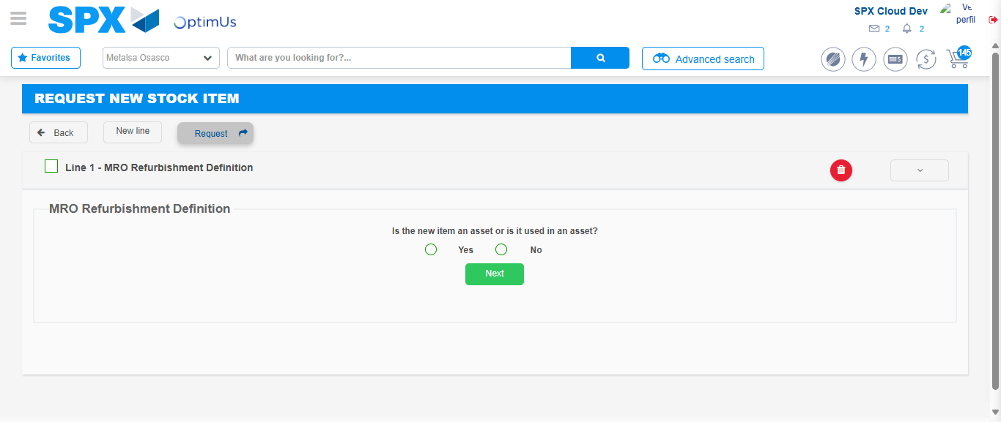Image file-name: QC_Testing-tc001_SPX_Dev5_Crear_Solicitud_Articulo_Almacen-1787864131646

Step 4 - Select options section location and position: Options seleted correctly
Image file-name: QC_Testing-tc001_SPX_Dev5_Crear_Solicitud_Articulo_Almacen-1787864131457

Image file-name: QC_Testing-tc001_SPX_Dev5_Crear_Solicitud_Articulo_Almacen-1787864131646

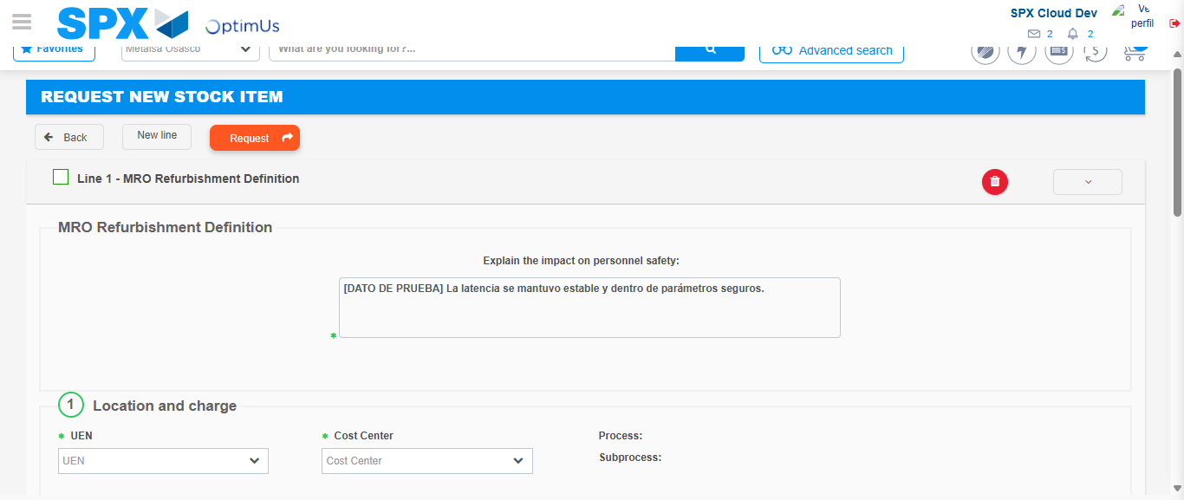Image file-name: QC_Testing-tc001_SPX_Dev5_Crear_Solicitud_Articulo_Almacen-1787864137473

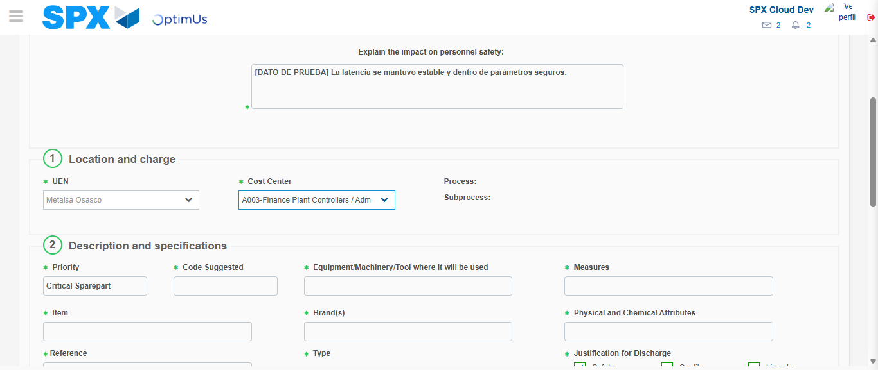Image file-name: QC_Testing-tc001_SPX_Dev5_Crear_Solicitud_Articulo_Almacen-1787864139883

Step 7 - Return to Main Page SPX : Return to Main Page SPX
Image file-name: QC_Testing-tc001_SPX_Dev5_Crear_Solicitud_Articulo_Almacen-1787864109958

Image file-name: QC_Testing-tc001_SPX_Dev5_Crear_Solicitud_Articulo_Almacen-1787864110498

Image file-name: QC_Testing-tc001_SPX_Dev5_Crear_Solicitud_Articulo_Almacen-1787864131152

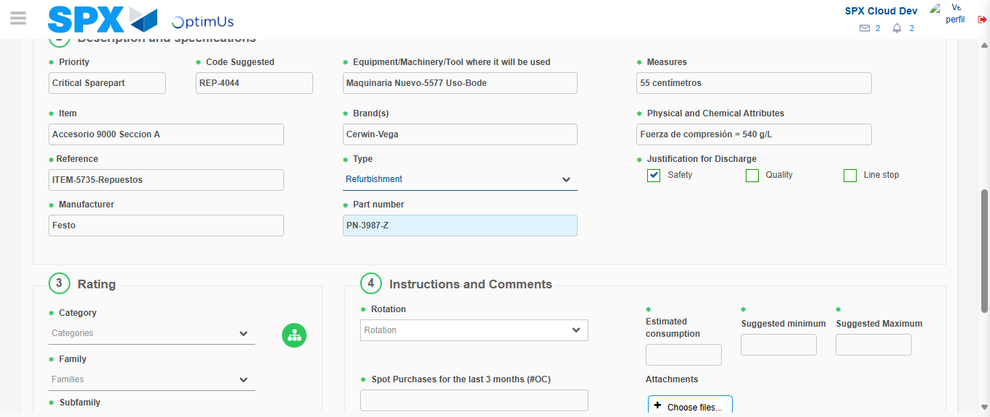Image file-name: QC_Testing-tc001_SPX_Dev5_Crear_Solicitud_Articulo_Almacen-1787864143172

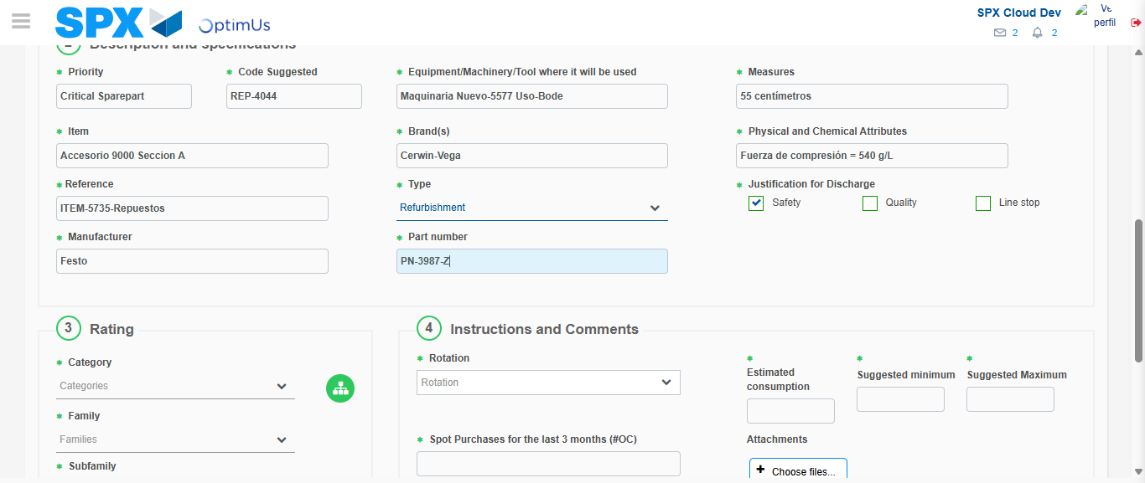Image file-name: QC_Testing-tc001_SPX_Dev5_Crear_Solicitud_Articulo_Almacen-1787864143339

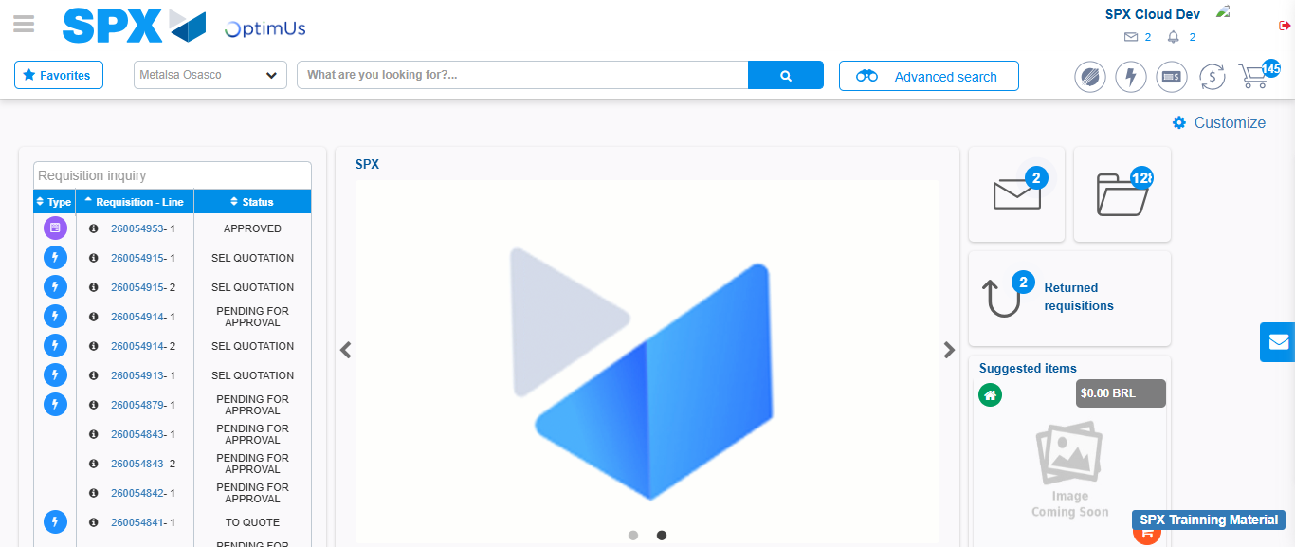Image file-name: QC_Testing-tc001_SPX_Dev5_Crear_Solicitud_Articulo_Almacen-1787864164511

Step 8 - Log Out : Log Out SPX
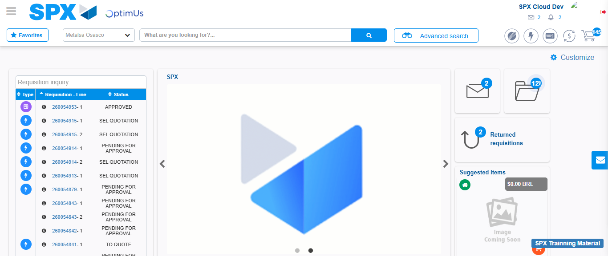Image file-name: QC_Testing-tc001_SPX_Dev5_Crear_Solicitud_Articulo_Almacen-1787864164818

